ˆ_ ProjectInformation DAAssignment-3

**TeamID:**  LTVIP2025TMID60948

**TeamLeader:**Satya Venkat Musudi

**Teammember:**Sireesha Tandala

**Teammember:**Sneha Deepthi Sri Alluri

**Teammember:**Sri Harsha Kodela

DatasetLink: <https://drive.google.com/file/d/1UmrCVmQFQYorNUTw414G3xot6rm46BwR/view>

¡]⬛#VisualizationScreenshots

# ⬛¡]# 1.KPI-FocusedInterface

Showskeymetrics—TotalSales,GrossIncome,Quantity—withtrendindicators,gauges,andsymbol charts. Great for a high-level snapshot of branch-wise performance.

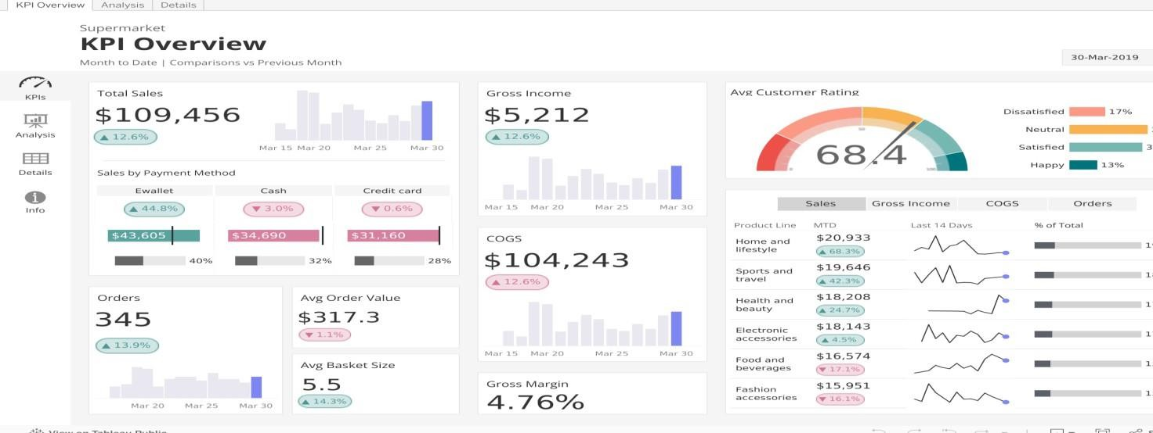

# ⬛#Z2.Multi-ComponentRetailDashboard

Combinesareacharts,barcharts,andfilterablelistsinacleanlayout.Offersdynamicfilteringby branch, category, or time period.

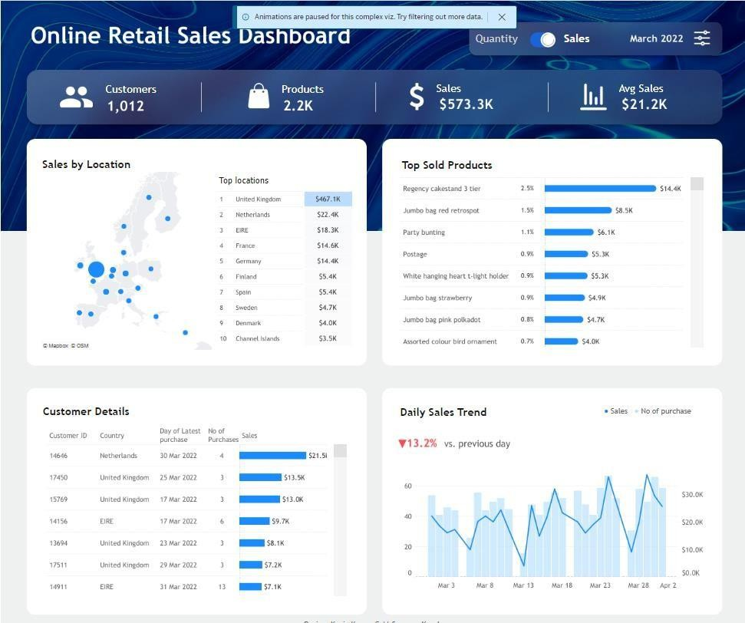

# ⬛⬛ª_]¸3.Time-BasedSales&PaymentsView

Includesmonthlytimelineswithstackedbarsandsidepanelsforpaymentmethodsorproduct lines—ideal for trend and distribution analysis.

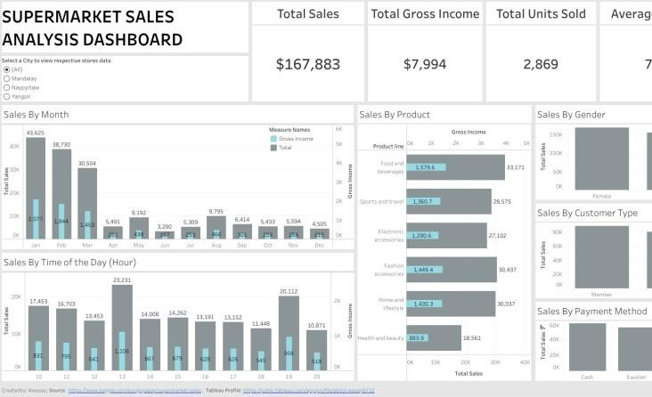

# ◉’●4.Dark-ThemedExecutiveDashboard

Featuresslickaestheticswithbartrends,KPIs,andproduct-levelinsights—perfectformanagement reporting.

